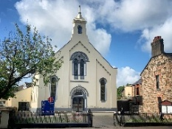


Regent Street
Methodist Church
Sunday 26th April 2026

Welcome and Announcements
Call To Worship
Opening Hymn HP 575 “Come let us with our Lord arise”
Opening Prayers
Old Testament Reading Ezekial 34:1-10
Praise Group The Lord’s My Shepherd
Goodness of God
Children’s Talk
Offering
(Children can leave for Crèche, Sunday School and Young Peoples Group)
New Testament Reading John 10:11-18
Hymn HP 535 “Master Speak”
Sermon
Prayers of Intercession
Hymn HP 79 “O loving God, who are for ever seeking”
Benediction

We have Crèche, Sunday School and Young Peoples Group that meet in our Halls, there will be an opportunity to go out during the Service to these groups.
JUST VISITING and want further information or require the Minister pastorally? The Rev’d Colin Milligan can be reached at ☎️ 028 91815959 or colin.milligan@irishmethodist.org

Please be aware that we live stream our services and so we can’t guarantee that you won’t be very occasionally caught on camera.

"Please add your name to the sign up in the foyer to help understand catering numbers. We hope that our church numbers along with all the churches in the Circuit will make this a great event"

