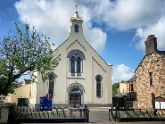

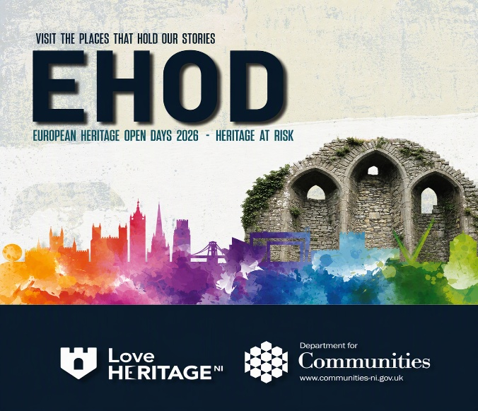

Church & Halls Cleaning
We are planning another Big Clean of our church property, and we would love your help! Could you spare a couple of hours to help us spruce up our church and halls? Whether you can help with cleaning, washing, or dusting, every pair of hands makes a difference.
📅 Wednesday 30 September from 2.00 pm
📅 Thursday 1 October from 7.00 pm
If you can come along for either session, your help would be greatly appreciated.
Many hands make light work! Thank you for helping us care for our church facilities.

Church Car Park
Little Ark, our parent & toddler group continues to be very popular with families from our local community, and Wednesday mornings are particularly busy in the church car park. To help us provide a welcoming experience for all who attend, we kindly ask our church family to leave the car park free until after 12.30pm on Wednesdays where possible. Thank you for supporting this important ministry.

Use Of Halls
Our Church Halls continue to serve the wider community through a number of local initiatives.
On Monday mornings and afternoons, we facilitate Family Contact Sessions in partnership with Family Support within the Health Trust. In addition, on Thursday afternoons we host a Strength and Balance Course delivered by the Multi-Disciplinary Team. This programme will initially run for four weeks.
Through our Have Your Say Questionnaire, many of you expressed a desire for our church to become more community-minded and to build stronger partnerships with others. We are delighted that these initiatives provide opportunities for us to do exactly that, enabling us to serve our community while working alongside local organisations.

Please be aware that we live stream our services and so we can’t guarantee that you won’t be very occasionally caught on camera.

Regent Street
Methodist Church
Sunday 27th September 2026
World Development & Relief Service

Welcome and Announcements
Call to Worship (Screen)
Hymn HP 139 “The Kingdom of God is justice and joy”
Old Testament Reading Isaiah 35:1-7
Praise Time Everlasting God
I will offer up my life
Children’s Time
Offering
(Children can leave for Crèche, Sunday School and Young Peoples Group)
New Testament Reading John 4:4-14
Video - Dabane (Zimbabwe)
Thought
Prayer for Others
Hymn MP 806 “Beauty for brokenness”
The Blessing
We have Crèche, Sunday School and Young Peoples Group that meet in our Halls, there will be an opportunity to go out during the Service to these groups.
JUST VISITING and want further information or require the Minister pastorally? The Rev’d Colin Milligan can be reached at ☎️ 028 91815959 or colin.milligan@irishmethodist.org

